Mersey Primary Academy
SEND Policy

Date issued | 8.9.20
EAB Approved
Review Date | 10.9.21

SEND Policy 2020 - 2021
Introduction
At Mersey Primary Academy we believe every pupil with a special educational need or any disability has an entitlement to fulfil his/her full potential. This is achieved by ensuring the wellbeing of all pupils in relation to: being healthy, staying safe, enjoying and achieving, making positive contributions and achieving social and economic wellbeing.
Mersey Primary Academy provides a broad and balanced curriculum for all children. Teachers set suitable learning challenges and respond to children’s diverse learning needs. Mersey recognise that some children may have barriers to learning that mean they have a special need which may require particular action by the Academy.
Children may have a special educational need throughout or at any time during their school career. This policy outlines the planning, identification, assessment and provision needed for any child who experiences difficulties.
Definition of Special Educational Needs (SEN):
“A child or young person has SEN if they have a learning difficulty or disability which calls for special educational provision to be made for them. A child of compulsory school age or a young person has a learning difficulty or disability if they:
a) have a significantly greater difficulty in learning than the majority of others of the same age; or
b) have a disability which prevents or hinders them from making use of educational facilities of a kind generally provided for others of the same age in mainstream schools or mainstream post-16 institutions.”
The Code of Practice 2014 describes four broad areas of SEN:-
1. Communication and Interaction, including speech, language and communication needs (SLCN) and Autism Spectrum Disorder (ASD).
2. Cognition and Learning, including severe learning difficulties (SLD), profound and multiple learning difficulties (PMLD), Specific Learning difficulties (SpLD), including Dyslexia.
3. Social, mental and emotional health, including attention deficit disorder (ADD), attention deficit hyperactivity disorder (ADHD), as well as other issues that are rooted in mental health.
4. Sensory and/or physical needs, including a range of physical difficulties (PD) as well as hearing impairment (HI), visual impairment (VI) and multi-sensory impairment (MSI).
A pupil may have difficulties in more than one of these areas, but usually there is a primary need with other additional needs. This policy aims to address the needs of these pupils. As a staff, we accept that the responsibility for meeting the educational needs of all students in our classroom lies with us.

The Equality Act of 2010 states that a person has a disability for the purpose of the Act if they have a physical or mental impairment, which has a substantial and long-term effect on his or her ability to carry out normal day-to-day activities. Having a disability does not automatically mean that a child will have a special educational need; if it does not affect their access to the curriculum and progress, it is not a special educational need.
Although there are acknowledged links – in some instances – with pupils who have English as Additional Language needs, this is a separate area of provision and is, accordingly, addressed in a different policy document. Children with EAL should not be regarded as having SEN, although pupils with EAL may also have SEN.
Figure 1 - 4 Areas of Need

Aims
1. To ensure that the Academy meets the needs of the Code of Practice 2014 and any updated advice from the Government.

2. To ensure the planned curriculum of the Academy and environment is matched effectively to meet the needs of all children.

3. To ensure that the special educational needs of children are identified, assessed and provided for, as early as possible.

4. To monitor the provision for pupils with SEN and ensure that interventions for each child are reviewed regularly to assess their impact, the pupil’s progress and the views of the child, their teachers and their parents.

5. To provide support and advice to all teachers in order that they are able to provide matched activities for children with special needs and to build up a collection of evidence to support the procedures of the Code of Practice.

6. To ensure the SENCo works in close consultation with class teachers to set appropriate, and specific targets for children, recorded on their graduated approach and reviewed termly using both the child’s and teacher/parent views sheets.

7. To ensure that the Academy has adequate and appropriate resources to meet the needs of all children with SEN including those that are more-able and a system is in place to identify and purchase further equipment as necessary.

8. To establish and maintain a close working relationship with parents and outside agencies in order to provide maximum and effective support for individual children.

9. To ensure that our children have a voice in this process, taking into account their age and understanding.

10. To provide regular in-service training for staff in order to keep them informed of all new legislation and procedures and up-dated strategies, resources etc.

Roles and Responsibilities
Class Teacher
All teaching staff are responsible for the identification and initial assessment of children with SEN within their class. The class teacher will make provision for such children and ensure that they have full access to the curriculum.

He/ She is responsible for:
• Ensuring that all children have access to good/outstanding teaching and that the curriculum is adapted to meet your child’s individual needs (also known as differentiation).
• Checking on the progress of your child regularly through B-Squared assessments and teacher assessments to identify, plan and deliver any additional help your child may need (this could be: targeted work, additional support, adapting resources etc..) and discussing strategies with the SENCO as necessary.
• Ensuring that all members of staff working with your child in the Academy (for example TAs, NAPA staff, lunchtime supervisors) are aware of your child’s individual needs and/or conditions and what specific adjustments need to be made to enable them to be included and make progress. It is the teacher’s job to oversee this and ensure your children’s needs are being met at all times.
• Ensuring that all staff working with your child in the Academy are supported in delivering the planned work/intervention for your child, so they can achieve the best possible progress. This may involve the use of additional adults, outside specialist help and specially planned work and resources.
• Ensuring that the school’s SEND Policy is followed in their classroom and for all the pupils they teach with any SEND.

Special Educational Needs Co-ordinator (SENCo): (Miss Jeacock)

The SENCo co-ordinates SEN throughout the school.
She is responsible for:
- Co-ordinating all the support for children with special educational needs (SEN) and or disabilities, and developing the school’s SEND Policy to make sure all children get a consistent, high quality learning environment.
- Ensuring that parents are:
- involved in supporting your child’s learning
- kept informed about the support your child is getting
- involved in reviewing how they are doing
- part of planning ahead for them.
- Liaising with all teaching staff and other professionals who may be coming into school to help support your child’s learning e.g. The Speech and Language Therapy Service, Educational Psychologist, School Nurse etc and feeding this information back to you.
- Updating the school’s SEND record of need, (a system for ensuring all the special educational, physical and sensory needs of pupils in this Academy are known and understood) and making sure that there are excellent records of your child’s progress and barriers to learning.
- To provide specialist support for teachers and support staff in the Academy so they can help your child (and other pupils with SEN and/or disabilities in the Academy) to achieve their potential.
- Keeping Graduated Approach documentation up to date with class teacher’s support
- Helping with the assessment of children with SEN.
- Maintaining and updating resources for SEN, ensuring that staff have knowledge and access to the materials.
- Organising training for staff so they are aware and confident about how to meet the needs of your child and others within our Academy.
Academy Executive Principal (Mr Yeomans) and Head of Academy (Mrs Gordon)
The Executive Principal and Head of Academy are responsible for the day-to-day management of all aspects of the school’s work, including provision of children with SEN. More specifically they, in liaison with the SENCo, take responsibility for:
• The day to day management of all aspects of the Academy, this includes the support for children with SEN and/or disabilities. They will give responsibility to the SENCo and class teachers but are still responsible for ensuring that your child’s needs are met.
• They must make sure that the Academy Advisory Body (AAB) is kept up to date about any issues in the school relating to SEND.
• To establish funding priorities, in line with the delegated SEN budget to ensure provision for children with SEN.
The Academy Advisory Board (AAB).(Chair of Governors – Mr Shane Davy) (SEN Governor – Mrs Midgley-Wright)
The AAB has important statutory duties towards pupils with SEN.
They are responsible for:
• Making sure that the Academy has an up to date SEND Policy.
• Making sure that the Academy has appropriate provision and has made necessary adaptations to meet the needs of all children in the Academy.
• Making sure that the necessary support is made for any child who attends the Academy who has SEN and/or disabilities.
• Making visits to understand and monitor the support given to children with SEND in the Academy and being part of the process to ensure your child achieves his/her potential in Academy

Identification, Assessment, Provision and Record-Keeping:

Mersey Primary Academy follows the Code of Practice (2014) in operating a graduated approach to identifying, assessing and supporting pupils with special needs. Figure 2 below illustrates the graduated stages of special education needs. All staff have a responsibility for identifying and supporting students with Special Educational Needs; however, class teachers have the overall responsibility of ensuring that the curriculum will be differentiated and delivered in an inclusive way.
Assess, Plan, Do, Review: A Graduated Response to SEN
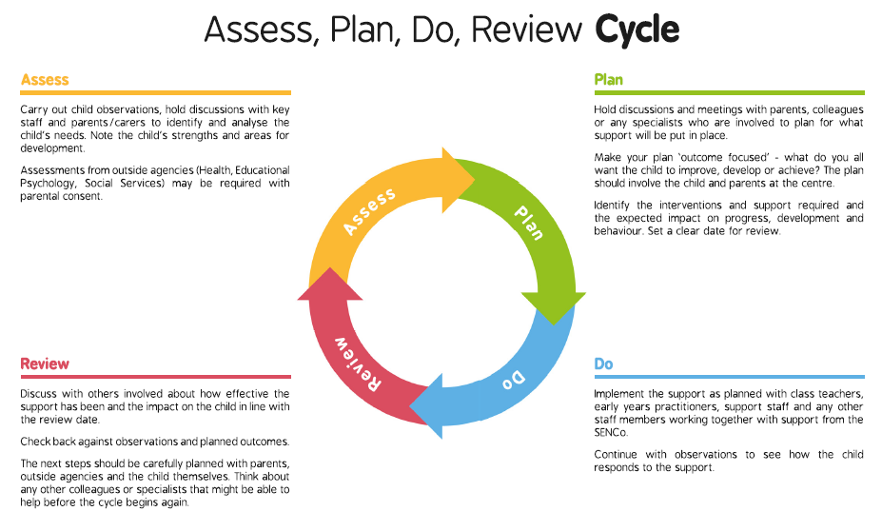
Figure 2 - Assess-Plan-Do-Review Cycle
Pupils are assessed using teacher assessments, assessments carried out by specialists within the school e.g. SENCo and/or assessments by external professionals. A plan is then put into place (in liaison with staff, parents and where appropriate, the child) stating the provision and strategies that will be employed to enable the child to overcome their barriers to learning and make good progress. The plan of support will be reviewed regularly and outcomes will be assessed.

Cause for Assessment
If your child has not made satisfactory progress and has significantly greater difficulty in learning than the majority of children of the same age, it may be decided to place the child on to Phase 1 of the Graduated Approach. This involves the child, the class teacher and the parents/carers. This will begin the assess, plan, do, review cycle. There may be the following triggers that alert class teachers to the fact that a child is experiencing difficulties:

• Making little or no progress despite different approaches to learning being provided
• Child works significantly below that expected for their age and stage
• There are persistent emotional/behavioural difficulties despite different strategies being used.
• There may be sensory or physical problems, or be little or no progress made despite additional aids, equipment and advice.

In addition to the above, a child may be identified as potentially requiring SEN provision as a result of the following:
• Teacher and TA observations evidence and data
• previous schools data/reports
• parental concerns
• records of progress
• screening / testing procedures
• information from other agencies
• end of Foundation stage profiles, KS1 data
At this stage teachers should assess the need of the pupil, set up relevant programmes of work, monitor progress and build up a bank of evidence that should be given to the SENCo. Parents/Carers will be made aware of the concerns noted in school and will be invited to take part in the planning stages of provision. A Phase 1’ of the Graduated Approach pro forma will then be completed. Where appropriate, this will be completed with the child. Progress towards agreed outcomes for the child will be reviewed and updated regularly. Parents/carers will also be kept informed through liaison with the class teacher informally, and at Parents Evenings when advice and support in helping their child at home can be given.
After 2 terms of ongoing support and provision provided by the class teacher, if the child is not making sufficient progress towards the outcomes, the child will then be placed on the SEN register and a meeting will be held with the child, class teacher, parents and the SENCo. When initiating Phase 2 of the Graduated Approach, desirable outcomes will be set for the child, class teachers will be provided with additional information and resources from the SENCo if necessary. The outcomes will be reviewed on a termly basis in a Review Meeting with the SENCo, the child, the class teacher and parents/carers/
When reviewing progress towards agreed outcomes, if despite additional input, it is felt that more specialist support is required; the school may decide to call on outside specialist support agencies to help the child make progress. These can include:
• Educational Psychologist
• Referral units
• IPaSS (Physical, Hearing or visual needs)
• Autism Outreach Team
• Speech and Language Service

Education, Health and Care Plans (EHC Plan)
If despite input at the above stages, adequate progress has not been made and the child’s SEN remains significant, a request will be sent to the Local Authority (LA) to consider a Statutory Assessment. A Statutory Assessment is a multi-professional assessment of a child’s needs and the help that is required to support them.
If the child meets the criteria in the Statutory Assessment for an EHC Plan, the LA will issue a EHC Plan detailing the needs of the child, what provision will be made for them, aims and objectives, and the level of support / funding required.
The funding that may accompany an EHC Plan does not have to be spent on providing a teaching assistant for individual support and may be spent on providing resources/training, whatever is best to meet the needs of the child.
Once the EHC Plan is issued, a planning meeting takes place within 8 weeks to discuss provision and targets for the following year. The EHC Plan is then reviewed annually. Children who are in the Early Years have their EHC Plans reviewed every 6 months.
Record Keeping
All files are kept in a secure, online folder. Each child has a folder containing all relevant information. The information in this folder will pass through the school with the pupils until they reach the 6th year when the information will be passed on to the relevant secondary school. This system ensures a whole school approach.
In a centralised place (the SENCo’s office), master copies of the records, details of standardised tests and where appropriate, medical records, are kept. Other records will include copies of the Graduated Approach paperwork, full EHC Plans, annual reviews and reports from professionals.
The Academy uses the B-Squared assessment tool on a half-termly basis to inform targets and outcomes which will be utilised to complete Graduated Approaches and reviews.
SEN Budget/Resources
Currently, the SEN Budget with the Pupil Premium is utilised to provide the following resources to support SEN provision in general and also those children eligible for free school meals and those children in Looked After Care (LAC) with or without SEN :
• Trained support staff.
• Assessment tools for identifying specific difficulties of pupils with SEN (BPVS, PhAB).
• Educational Psychologist time to support high priority pupils.
• School nurse support for pupils with behavioural and emotional difficulties, sensory and physical difficulties but also to provide support in general to parents/carers of pupils with SEN.
• SENCo time.
• Specific interventions.
Transitions
When pupils transfer to another primary school, all documents and records are sent to the receiving school. If the destination is unknown, records are kept securely until information is received. A transition document provided by the LA is also completed and telephone conversations between the SENCo and the SENCo from the receiving school are sought whenever possible.
When transferring to secondary school the transfer liaison teachers visit the Academy and speak to the Y6 teacher and where possible, to the SENCO. If a personal interview is not possible then a telephone conversation imparts any relevant information. All SEN records along with a completed transition document are sent to the secondary schools. The transition document is completed, when possible, with parents/carers and pupils in order to provide reassurance and allow for the transfer of accurate information.
Liaison with Parents/Carers
Parents/carers are invited to a meeting with the SENCo and class teacher to discuss any issues or concerns termly. Parent/carers are then updated regularly should their child’s SEN status be changed. Parents/carers will also be kept informed through liaison with the class teacher informally, and at Parents Evenings when advice and support in helping their child at home can be given. Parent/carers will be involved in reviewing their child’s Graduated Approach and any comments will be taken into account. New Graduated Approaches will be sent home as appropriate.
Voice of the Child
“It is very important to engage directly with children and young people to discuss their needs, and plan how they can achieve the best outcomes. This should be integral to all planning for children and young people with SEN throughout their lives.”
(SEN Code of Practice, 2014).
Pupils at Mersey Primary are therefore involved in discussing their provision and what they feel will help them achieve their full potential. Pupils are invited to review meetings (where appropriate) and are made to feel that they can contribute/have an opinion about their support at Mersey. Where the child may be unable to verbally communicate or provide a written input, observations of pupils are made during child initiated times in order to gather information regards their likes, dislikes and difficulties. Pupil voice interviews also occur termly.
This policy is reviewed annually by the SENCo, Academy Executive Principal, Head of Academy and the EAB.
Issued: 8.9.20
Review: 10.9.21

Appendices
Appendix A: Graduated Approach Phase 1
Appendix B: Graduated Approach Phase 2

Appendix 1
Appendix 1
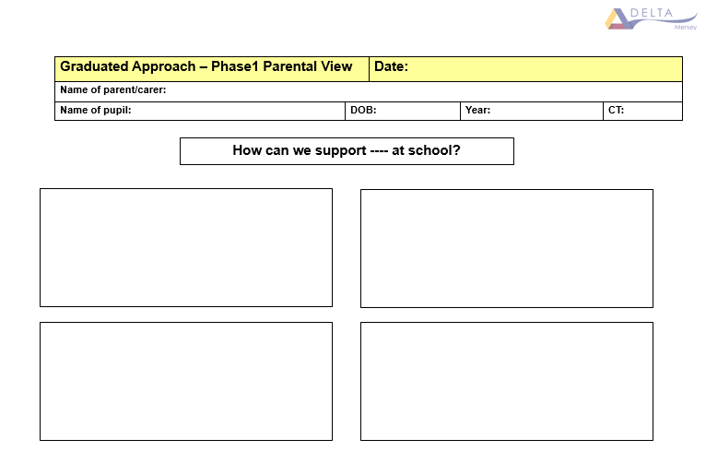
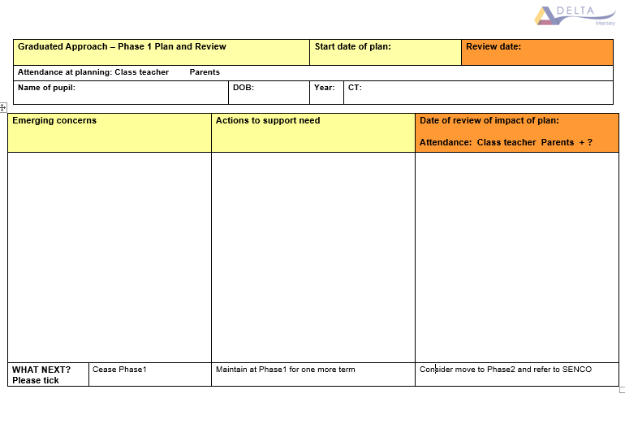
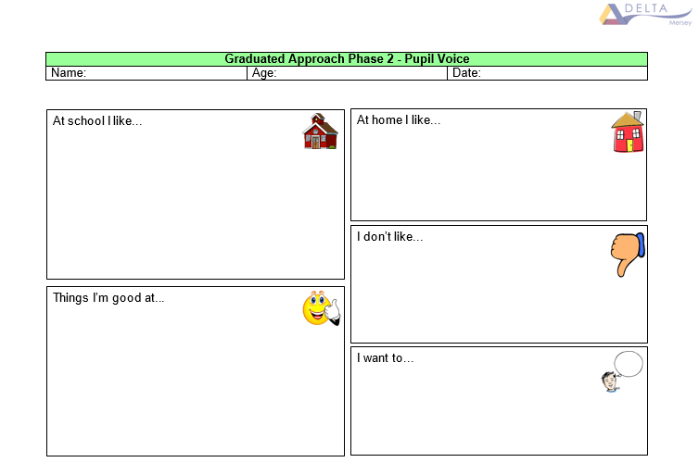
Appendix 2
